EXPERIMENT 2

Demonstrate the statistics for a sample data like mean, standard deviation, normal/uniform distribution, variance and correlation.

AIM
To demonstrate basic descriptive statistics including mean, variance, standard deviation, and correlation using the Students Performance dataset, and visualize the distributions.

PROCEDURE
- Import pandas, matplotlib, and math libraries.
- Load the StudentsPerformance.csv dataset using pd.read_csv().
- Extract math scores and reading scores as arrays.
- Compute the mean of math scores manually using a loop.
- Compute the variance of math scores manually.
- Compute the standard deviation using math.sqrt().
- Plot histogram of math score distribution.
- Plot histogram of reading score distribution.
- Compute the mean of reading scores.
- Calculate the Pearson correlation coefficient between math and reading scores manually.
- Visualize the correlation using a scatter plot.

CODE

import pandas as pd
import matplotlib.pyplot as plt
import math
df = pd.read_csv('StudentsPerformance.csv')
df.head()
math_scores = df['math score'].values
reading_scores = df['reading score'].values
n = len(math_scores)
# Mean
sum_math = 0
for x in math_scores:
sum_math += x
mean_math = sum_math / n
# Variance
var_sum = 0
for x in math_scores:
var_sum += (x - mean_math) ** 2
variance_math = var_sum / n
# Standard Deviation
std_math = math.sqrt(variance_math)
# Histogram of Math Scores
plt.hist(math_scores, bins=30)
plt.title('Distribution of Math Scores')
plt.xlabel('Math Score')

plt.ylabel('Frequency')
plt.show()
# Mean of Reading Scores
sum_reading = 0
for r in reading_scores:
sum_reading += r
mean_reading = sum_reading / n
# Pearson Correlation
num = 0; den_x = 0; den_y = 0
for i in range(n):
num += (math_scores[i] - mean_math) * (reading_scores[i] - mean_reading)
den_x += (math_scores[i] - mean_math) ** 2
den_y += (reading_scores[i] - mean_reading) ** 2
correlation = num / math.sqrt(den_x * den_y)
# Scatter Plot
plt.scatter(math_scores, reading_scores)
plt.xlabel('Math Score')
plt.ylabel('Reading Score')
plt.title('Correlation Between Math and Reading Scores')
plt.show()

OUTPUT
Mean (Math): | 66.089
Variance (Math): | 229.6897900000004
Std Dev (Math): | 15.155496659628165
Correlation (Math | vs Reading): 0.8175796636720533
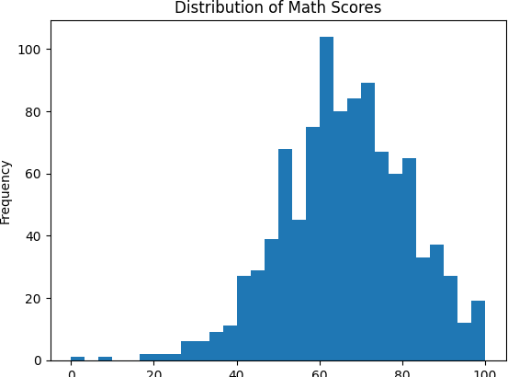
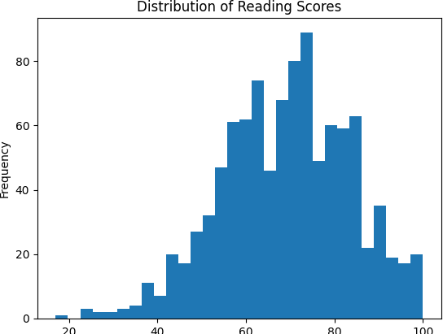

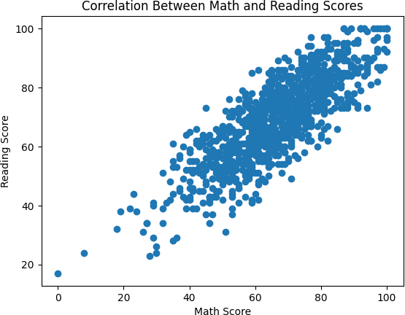

RESULT
The mean math score was 66.089 with a standard deviation of 15.15. A strong positive Pearson correlation of 0.818 was found between math and reading scores, suggesting students who perform well in math also tend to perform well in reading.

